HPE ProLiant Compute Gen12 Components
Where are they located?

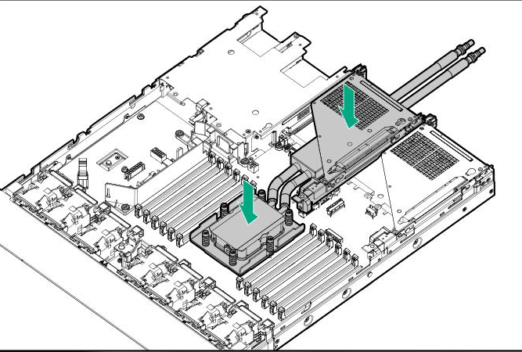

Where are they located?
- Location: Directly on top of the CPU, beneath or instead of the conventional heatsink assembly.
- Function: They transfer heat from the processor to a circulating liquid coolant.
- Connection: Tubes connect the cold plates to the liquid-cooling distribution system.
- Visibility: They may not be present in a standard air-cooled server.
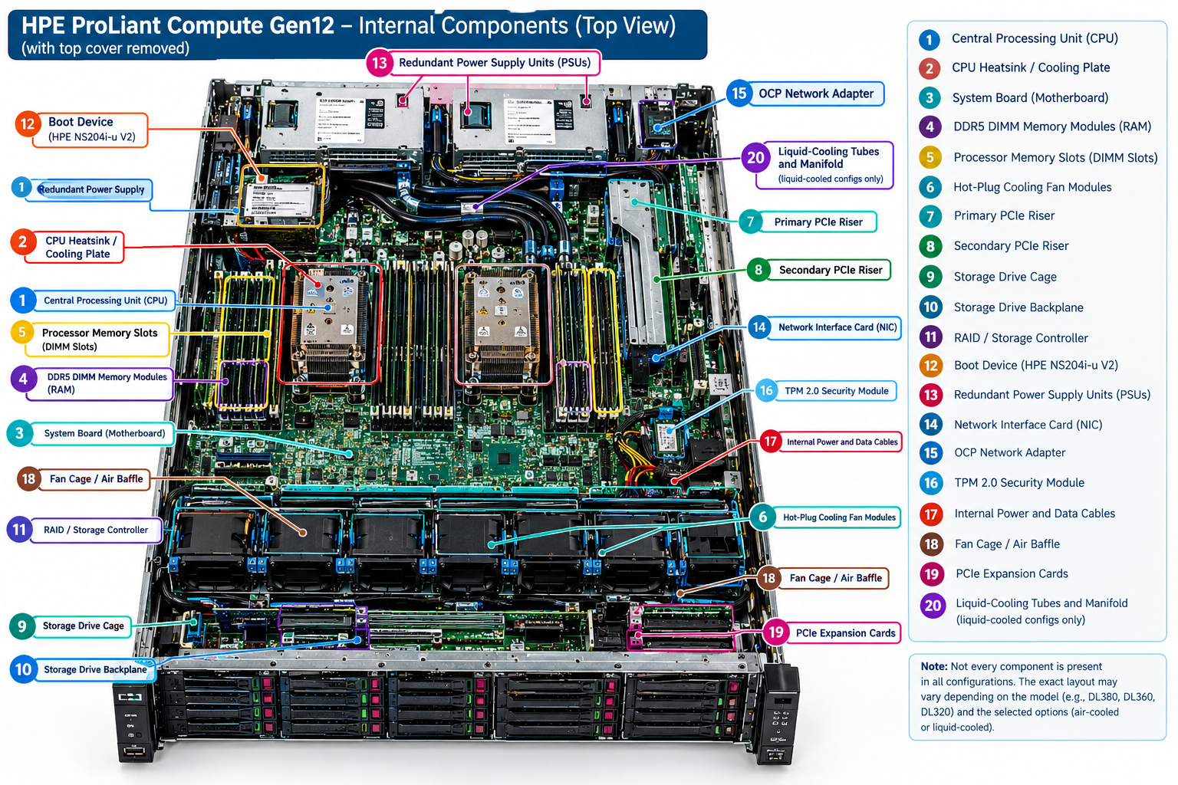

HPE ProLiant Compute Gen12 Internal Components Explained
No. | Component | One-line explanation
1 | CPU (Central Processing Unit) | Executes instructions and processes workloads such as virtual machines, databases, and applications.
2 | CPU Heatsink / Cooling Plate | Removes heat from the CPU using airflow through a heatsink or liquid coolant through a cooling plate.
3 | System Board (Motherboard) | The main circuit board that connects the CPU, RAM, storage, networking, and other hardware.
4 | DDR5 DIMM Memory Modules (RAM) | Temporarily stores the data and instructions that the CPU needs while applications are running.
5 | DIMM Slots | Hold the RAM modules and connect them to the processor's memory channels.
6 | Hot-Plug Cooling Fan Modules | Circulate air through the server to prevent components from overheating.
7 | Primary PCIe Riser | Provides expansion slots for compatible network cards, storage controllers, and other PCIe devices.
8 | Secondary PCIe Riser | Provides additional expansion slots when supported and installed in the server configuration.
9 | Storage Drive Cage | Physically holds the server's storage drives in their designated bays.
10 | Storage Drive Backplane | Connects installed drives to the server's storage and power connections.
11 | RAID / Storage Controller | Manages supported storage drives and can configure RAID arrays for performance or redundancy.
12 | Boot Device (HPE NS204i-u V2) | Provides dedicated boot storage for the operating system in supported configurations.
13 | Redundant Power Supply Units (PSUs) | Convert incoming AC electricity into the DC power required by the server's components.
14 | Network Interface Card (NIC) | Connects the server to a network through Ethernet ports for communication with other systems.
15 | OCP Network Adapter | Provides network connectivity through a supported OCP adapter installed in its dedicated slot.
16 | TPM 2.0 Security Module | Provides hardware-based security functions, including support for cryptographic keys and platform integrity checks.
17 | Internal Power and Data Cables | Carry electrical power and data signals between internal components.
18 | Fan Cage / Air Baffle | Guides airflow through the chassis so cooling air reaches the components that need it.
19 | PCIe Expansion Cards | Add capabilities such as high-speed networking, storage connectivity, or specialized processing.
20 | Liquid-Cooling Tubes and Manifold | Distribute liquid coolant to supported cooling plates and carry heated coolant away in liquid-cooled configurations.
Remember these five basics:
- CPU = Processing
- RAM = Temporary working memory
- Storage = Permanent data storage
- NIC = Network connectivity
- PSU = Electrical power
.

GPU Coolant Plate (Liquid Cooling)

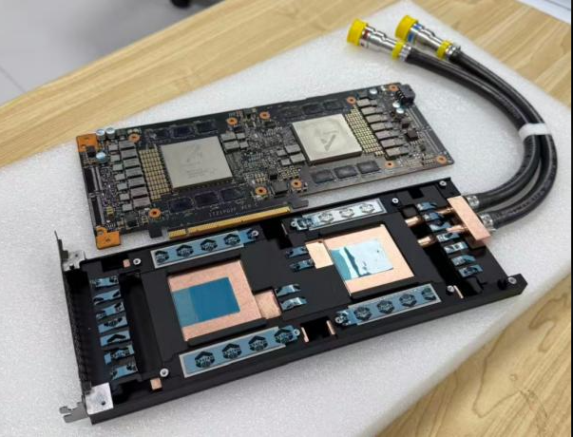
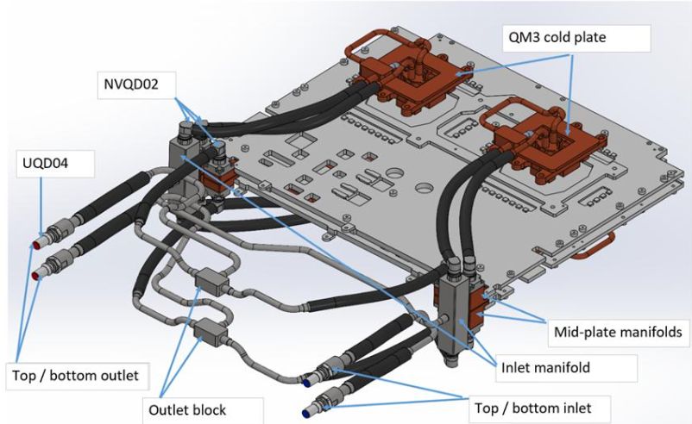

- QM3 Cold Plate: Absorbs heat directly from server components using circulating coolant.
- NVQD02: Quick-disconnect fittings that connect coolant lines to the cold-plate circuit.
- UQD04: Universal quick-disconnect connector for connecting coolant supply or return lines.
- Inlet Manifold: Distributes incoming coolant to the required cooling circuits.
- Mid-Plate Manifolds: Route coolant between the inlet/outlet connections and cold plates.
- Top/Bottom Inlet: Connections that supply cold coolant into the cooling system.
- Top/Bottom Outlet: Connections that carry heated coolant out of the cooling system.
- Outlet Block: Collects coolant returning from the cooling circuits and directs it toward the outlet connection.
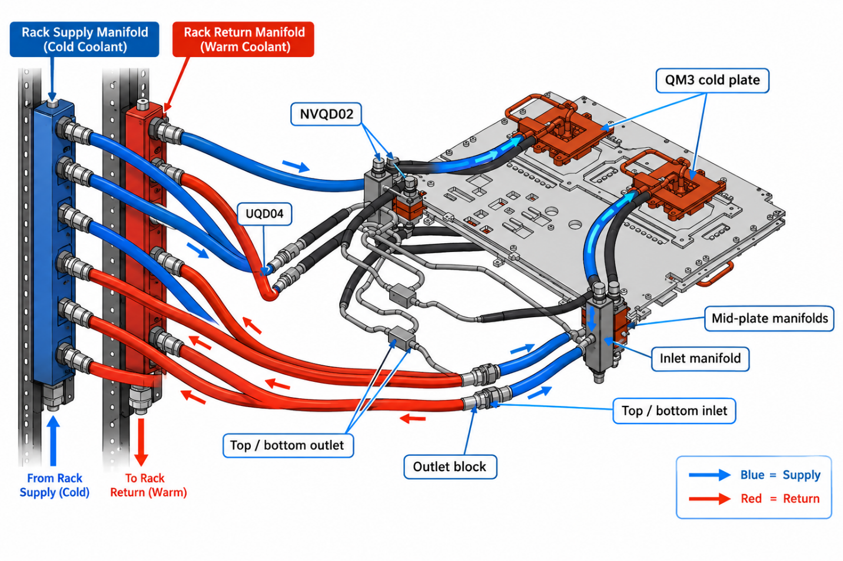
This visualization shows how the Rack Manifold connects to the server’s liquid-cooling assembly.
- Blue — Supply: Cold coolant flows from the rack supply manifold through supply hoses and quick-disconnect fittings to the inlet manifold and QM3 cold plates.
- QM3 Cold Plates: Coolant absorbs heat from the server components.
- Red — Return: Heated coolant flows out through the outlet block and return hoses to the rack return manifold.
- Quick Disconnects (UQD04/NVQD02): Allow secure, serviceable coolant connections between the rack and server assembly.

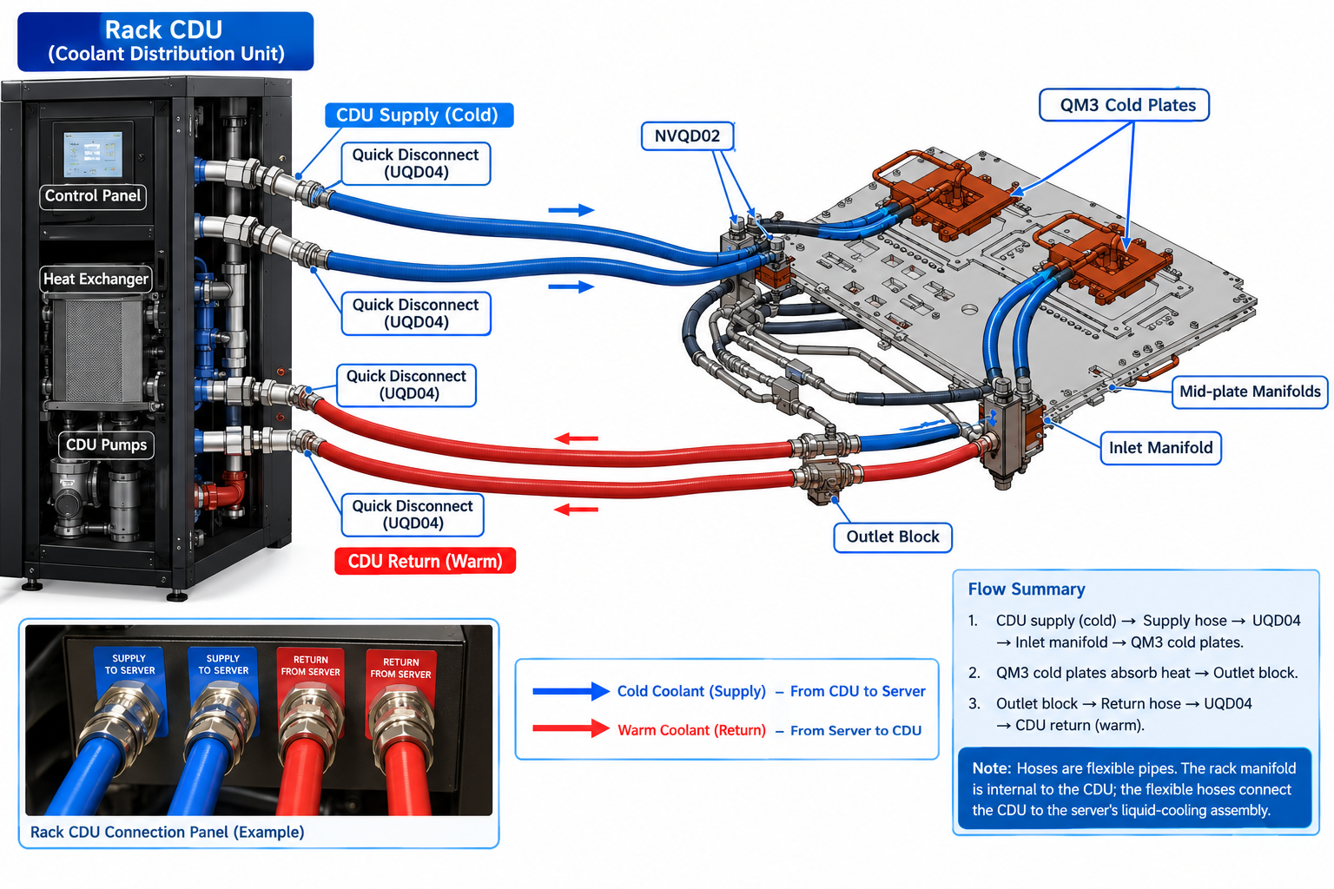
The Rack CDU (Coolant Distribution Unit) connects to the server’s liquid-cooling assembly through two separate hose circuits: cold coolant supply and warm coolant return.

Coolant connection flow
1. Cold coolant supply — Blue
Rack CDU supply port → Flexible hose → Quick-disconnect coupling (UQD04) → Server inlet manifold → QM3 cold plates.
2. Warm coolant return — Red
QM3 cold plates → Outlet block → Flexible return hose → Quick-disconnect coupling (UQD04) → Rack CDU return port.
The CDU’s pumps circulate the coolant, and its heat exchanger transfers heat away from the server coolant loop.

